**AQUA-DRIVE**

* **Problem Statement:**

Design and fabricate water rockets which cover the maximum range at a given pressure, in another round land at predefined spots.

You are allowed to make and use more than 1 model for different rounds.

* **Rules and Regulations:**
* Plastic bottles of 1.5ltr – 2.5ltr can be used for the main body.
* Metal sheets in any form cannot be used.
* Models should be handmade, readymade rockets will not be accepted.
* Your model can be of any size or shape and can be made of any material. But, it should not damage the arena or hurt any person. If your model is found dangerous, you will not be allowed to participate in the event.
* The water rocket may contain any of the following mechanisms suitable for different rounds:
* Gliding (wings type) mechanism
* Booster mechanism: in this case, participants should ensure that they have proper launchers supporting the launching mechanism
* Any other innovative mechanism will be encouraged provided that the material and mechanism used is not harmful or dangerous to any person in the field.

In this case the decision of the panel of coordinators will be final and no queries will be entertained in this regard.

* **Team Specifications:**

A team can consist of a maximum of 3 members.

Maximum 10 teams are allowed from each pool.

* **Arena:**

The Launch Zone for both rounds will be a circle of 1 m diameter. Arena for Round 2 will be 3 concentric circles with their center at a distance of 50 m from the launch zone Centre.

Region A – Circle of radius 2 m.

Region B – Ring of inner radius 2 m and outer radius 4 m with same center as circle A.

Region C – Ring of inner radius 4 m and outer radius 6 m with same center as circle A.

There is no specific arena for Round 1.

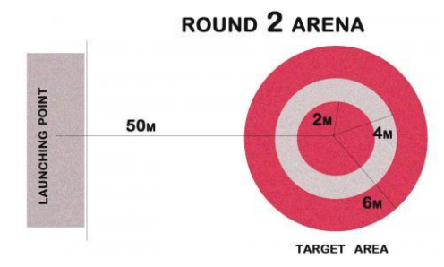

* **Event Structure:**

**Round 1 - Range**

The water rocket has to be launched from launch pad and will be tested for maximum horizontal range.

**Round 2- Spot Landing**

A specific range of the water rocket will be tested in this round. The rocket has to hit a provided target range marked on the ground as concentric circles. The center of the circles lies at a distance of 50 m from the launch point.

***Scoring Criteria:***

**Point Distribution for Round 1:**

Each team will be given a maximum of two trials. Best of the two trials will be considered as follows. The distance covered in meters will be directly equal to the points you score in this round. This score will be called “A”.

**Point Distribution for Round 2:**

The concentric circles will carry the following points:

Region A: 100 points

Region B: 70 points

Region C: 50 points

Anywhere out of the given three circles: 0 points

Each team will be given 2 trials. Best of the 2 trials will be considered. This score will be called “B”.

**Total = A + B**

**Useful Links:**

http://www.aircommandrockets.com/construction.htm http://www.youtube.com/watch?v=x8jrqAo8Xa8&feature=related http://www.youtube.com/watch?v=6db9kZh3EdU http://www.youtube.com/watch?v=m2ui8ITPlU8&feature=related http://students.iitk.ac.in/aeromodelling

**Note: In case of any disputes, the decision of the Coodinators would be final and binding to all.**

* **Contacts:**

Arpit Khunteta arpitr@iitk.ac.in +91 8960467870

Deepak Pawar deepaksp@iitk.ac.in +91 8960484303

Suraj Bhamare surajab@iitk.ac.in +91 9793972266

In case of any doubt, contact the secretary of your hall or any of us.